Mini-AAA **Un cuento infantil**

I can use the Spanish preterite to narrate a series of events in the past.

I can use clue words for preterite use in Spanish.

Use the Spanish **pretérito** and the vocabulary ‘pistas para el pretérito’ to narrate a series of events in the past in a children’s story. Each page in the story should have two sentences and an illustration that reflects what is said. Your story should be 5 pages long and also have a cover page with a title and illustration. Please number each page. Remember, this is a children’s story, plot isn’t that important.

* Cover page with Spanish title
* 5 numbered pages with 2 preterite sentences with preterite clue words
* Illustration on each page that matches the sentences
* Only Spanish in book
* Page 6 – numbered translation page

You may draw or use clip art or images from the internet. If you use clip art or images from the internet make sure that what you write is accurately reflected in the image. If your illustrations have different people in them, please make sure to give them different names.

On page six of your book, please translate your story to English, numbering the sentences to match the page numbers. **OJO – make sure to have ONLY SPANISH in pages 1-5 of your book**

*Ejemplos:*

|  |  |
| --- | --- |
| C:\Program Files\Microsoft Office\Media\CntCD1\ClipArt2\j0231422.wmf  Yo preparé el almuerzo esta mañana. Luego Felipe y yo comimos el almuerzo en el parque. | C:\Program Files\Microsoft Office\Media\CntCD1\ClipArt2\j0231631.wmf  ¡El año pasado hice muchas cosas interesantes!  El enero pasado esquié en Smugglers’ Notch con mis amigos. Me gusta mucho esquiar. |

|  |  |  |
| --- | --- | --- |
| **Description** | **Language Use** | **Use of required elements** |
| **HIGH** | * Excellent variety of sentence structure.  * Excellent command of grammar with very few errors.  * Excellent range of vocabulary. | Includes 100% of required elements and more. |
| **MID-HIGH** | * Good variety of sentence structure.  * Good command of grammar with a few errors.  * Good range of vocabulary. | Includes 100% of required elements. |
| **MID** | * Average variety of sentence structure.  * Average command of grammar with occasional errors.  * Average use of vocabulary. | Includes 90-80% of required elements. |
| **MID-LOW** | * Sentence structure is broken.  * Minimal command of grammar with many errors.  * Minimal use of vocabulary. | Includes 66-79% of required elements. |
| **LOW** | * Sentence structure interferes with comprehension.  * No command of grammar with pervasive errors.  * Limited use of vocabulary. | Includes less than 65% of required elements. |

**Imágenes que puedes usar.**

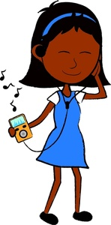C:\Program Files\Microsoft Office\Media\CntCD1\ClipArt2\j0231631.wmf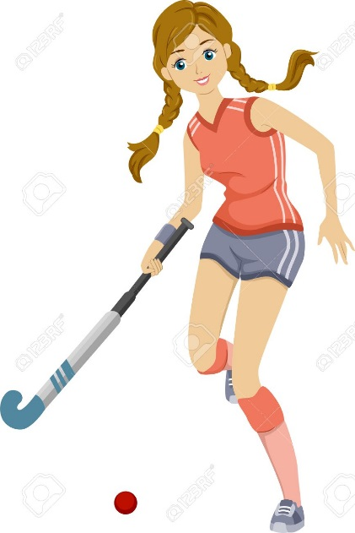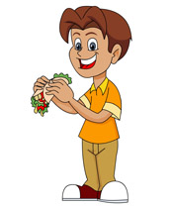C:\Program Files\Microsoft Office\Media\CntCD1\ClipArt2\j0231406.wmfC:\Program Files\Microsoft Office\Media\CntCD1\ClipArt2\j0231407.wmfC:\Program Files\Microsoft Office\Media\CntCD1\ClipArt2\j0231409.wmfC:\Program Files\Microsoft Office\Media\CntCD1\ClipArt2\j0231515.wmfC:\Program Files\Microsoft Office\Media\CntCD1\ClipArt2\j0231412.wmfC:\Program Files\Microsoft Office\Media\CntCD1\ClipArt2\j0231417.wmfC:\Program Files\Microsoft Office\Media\CntCD1\ClipArt2\j0231516.wmfC:\Program Files\Microsoft Office\Media\CntCD1\ClipArt2\j0231632.wmfC:\Program Files\Microsoft Office\Media\CntCD1\ClipArt2\j0231634.wmf

C:\Program Files\Microsoft Office\Media\CntCD1\ClipArt2\j0231422.wmfC:\Program Files\Microsoft Office\Media\CntCD1\ClipArt2\j0231458.wmfC:\Program Files\Microsoft Office\Media\CntCD1\ClipArt2\j0231524.wmfC:\Program Files\Microsoft Office\Media\CntCD1\ClipArt2\j0231519.wmfC:\Program Files\Microsoft Office\Media\CntCD1\ClipArt2\j0231526.wmfC:\Program Files\Microsoft Office\Media\CntCD1\ClipArt2\j0231527.wmf