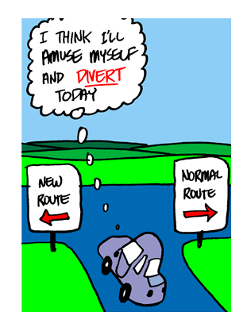
divertirse: to have fun (literally – to amuse one’s self)
The Spanish verb divertirse means 'to have fun' and is an irregular Spanish IR verb.
To remember this, imagine to have fun you DIVERT from the normal route!
This is a reflexive verb which is why you see the little words in front of the conjugations. They must be included!
VERB CONJUGATION TABLE DIVERTIRSE - to have fun
Simple Tenses - Spanish Verb divertirse
TENSE | yo | tú | él, ella, usted | nosotros | vosotros | ellos, ellas, ustedes
Present  Presente  …have fun | me divierto | te diviertes | se divierte | nos divertimos | os divertís | se divierten
Preterit  Pretérito  …had fun | me divertí | te divertiste | se divirtió | nos divertimos | os divertisteis | se divirtieron
Imperatives Spanish Verb divertirse - to have fun
Imperative  Imperativo  have fun! |  | ¡diviértete! | ¡diviértase! | ¡divirtámonos! | ¡divertios! | ¡diviértanse!

So let’s put this vocab into use. Write the following in Spanish.
I have fun.
We have fun.
You have fun.
We have fun in Spanish class.
My friends have fun when they dance.
My family has fun at a party.
VERB CONJUGATION TABLE LLAMARSE
To call oneself or, to be called or to be named
TENSE | yo | tú | él, ella, usted | nosotros | vosotros | ellos, ellas, ustedes
Present
Presente

¡Más práctica! Write the following in Spanish.
My name is Gloria
The dog’s name is Zeus
My parent’s names are Isabela and Miguel
My favorite book is called The BFG
They are called feminists

