Español 2 Nombre___________________________ Modo __________

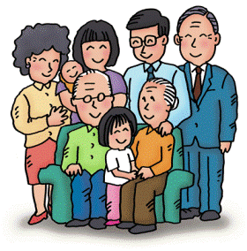**AAA – Writing and speaking Undiad: La Familia y sus fiestas**

1. In a paragraph of about 110-130 words describe the people, things and activities that you see in painting below. [Do not translate the model paragraph to Spanish!]

* Describe the personality and physical characteristics of some of the people.
* You can write this as if you are a member of the family or as an observer of the party.
* At least 2 of your sentences must have PLURAL subjects. (ellos, nosotros).
* Give each person a name and explain who they are in the family in relation to other people in the painting (use ‘de’).
* Focus on using vocabulary from your packet. You should not really need to go looking for other words

You must show your mastery of the learning targets in your writing C:\Users\turnerk\AppData\Local\Microsoft\Windows\Temporary Internet Files\Content.IE5\94D6KTIO\MC900391148[1].wmf

**I can**

1. Describe physical and personality traits using the verbs ***ser*** and ***tener***
2. Describe conditions using the verb ***estar***
3. Name many different **family members**
4. Talk about members of a family in relation to one another using the preposition ***de***
5. Express what someone has using **possessive adjectives**
6. Describe **activities at parties** or celebrations

**Barbacoa para cumpleaños de Carmen Lomas Garza**

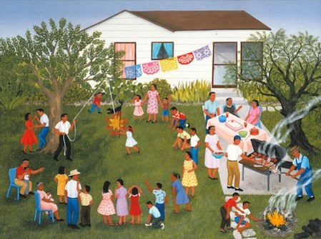

**Un ejemplo en inglés:** It is my cousin Susana’s birthday party. I am very excited. There is papel picado and a big cake. My uncles cook chicken. My cousin breaks her piñata. My younger cousins watch and my older cousins dance. My older cousins dance very well, they are talented and artistic. The grandparents of my family are Gloria Fernandez Blanco and Juan Felipe Zeledon Garcia. My grandmother is friendly and generous but quiet. She is short and patient and very funny. She has grey hair and small brown eyes. My grandfather has short brown hair and big green eyes. He doesn’t have glasses. He is nice and talkative but a little impatient. They watch their grandchildren. Their grandchildren are fun, short and young. My grandparents are in a good mood because it is a party.

You will write first draft and receive feedback using editing codes.

Your first draft is due Dec 8 for B days and Dec. 9 for A days.

The final draft is due December 17 for A day or December 18 for B day.

Before you turn in your 1st draft: CHECK the following!!!!!

* Have you used ser and tener in the appropriate places?
* Do your adjectives match the noun they are describing?
* Have you talked about people as a group?
* Are your verbs conjugated correctly?
* Did you use possessive adjectives?
* Did you use party vocabulary?

Rubric for written work

|  |  |  |  |  |
| --- | --- | --- | --- | --- |
| Extends beyond standard **A+ / A-** | Meets standard **B** | Working towards meeting standard **C** | Needs help to work toward meeting standard **D / D-** | Does not meet standard **I** |
| Well-organized and articulated. This entire written piece is appropriate and comprehensible.  Shows subject-verb agreement, noun-adjective agreement (number and gender), makes a conscious effort to use accents, no spelling errors.  Word order is entirely correct.  Makes use of new vocabulary and structures. Attempts to use a wide range of vocabulary.  Interesting, creative response.  Correctly applies feedback in all cases.  Work includes more than 100% of required elements. | Well-organized. Appropriate and comprehensible in most parts.  Communication is not affected by interference from English.  One or two grammatical errors in subject-verb agreement, noun-adjective agreement, word order or spelling. They are very minor and do not interfere with communication.  Good vocabulary. Makes use of appropriate words and some new lexical items.  Generally good response.  Applies feedback correctly in most cases.  Work includes 85-100% of required elements. | Expresses some ideas on the topic.  Elements are appropriate and comprehensible.  Contains more than a few grammatical errors.  No conscious effort to use accents.  Vocabulary is just adequate to respond. No attempt made to use a variety of expressions.  Generally understood but limited to the very basic.  Application of feedback is inconsistent.  Work includes 75- 84% of required elements. | Not very well-organized and ideas are poorly expressed even though it may be comprehensible.  Communication may be hindered by inadequate vocabulary and lack of proper use of irregular verb forms, spelling errors (accents lacking), and other basic errors.  Many errors in agreement (noun-adjective and number and gender), inappropriate verb forms used. These errors occur in structures that are basic at this level.  Inadequate vocabulary or incorrect use of lexical items, leading to a lack of communication.  Does not apply feedback.  Work includes 65- 74% of required elements. | This piece is not acceptable.  Most structures are incorrect. Constant use of the infinitive form of the verb, no evidence of knowledge of conjugation nor agreement.  Incomplete due to the lack of vocabulary. Answers tend to be one or two words in length.  Work includes less than 65% of required elements  Does not apply feedback.  Student must re-do work to earn credit. Grade will be recorded as **Incomplete** until minimum standard is achieved. |

1. **Speaking:**

Using the painting as a prompt tell your teacher about what you see in the painting. Describe the activities, items and people at the party.

Describe their looks and personality.

You may NOT use notes. You will be speaking off the top of your head.

Your teacher will have 2 or 3 questions for you.

Your goal is to speak as clearly and in as detailed a way as possible so you will need to PRACTICE, PRACTICE, PRACTICE.

**Languages Other Than English (LOTE)**

**Speaking Rubric**

|  |  |  |  |  |
| --- | --- | --- | --- | --- |
| **Score** | **Description** | **Fluency** | **Pronunciation** | **Language Use** |
| **5** | **HIGH** | * Outstanding fluency;  no hesitancy. | **\*** Outstanding  pronunciation with  very few errors. | * Excellent variety of sentence  structure.  * Excellent command of grammar  with very few errors.  * Excellent range of vocabulary. |
| **4** | **MID-HIGH** | * High level of fluency;  some hesitancy. | * High level of  pronunciation with a  few errors. | * Good variety of sentence  structure.  * Good command of grammar with a  few errors.  * Good range of vocabulary. |
| **3** | **MID** | * Good range of fluency;  hesitancy. | * Good range of  pronunciation with  occasional errors. | * Average variety of sentence  structure.  * Average command of grammar with  occasional errors.  * Average use of vocabulary. |
| **2** | **MID-LOW** | * Narrow range of fluency;  consistent hesitancy. | * Narrow range of  pronunciation with  many errors. | * Sentence structure is broken.  * Minimal command of grammar  with many errors.  * Minimal use of vocabulary. |
| **1** | **LOW** | * Poor range of fluency;  severe hesitancy. | * Poor pronunciation  with severe errors. | * Sentence structure interferes with  comprehension.  * No command of grammar with  pervasive errors.  * Limited use of vocabulary. |
| **0** | A speaking sample that receives this score may consist of no response within the suggested time length, profanity, an answer irrelevant to the original question, etc. | | | |