I can use ***IR a + infinitive*** to ask and talk about *near future* actions, what someone *is going to do*

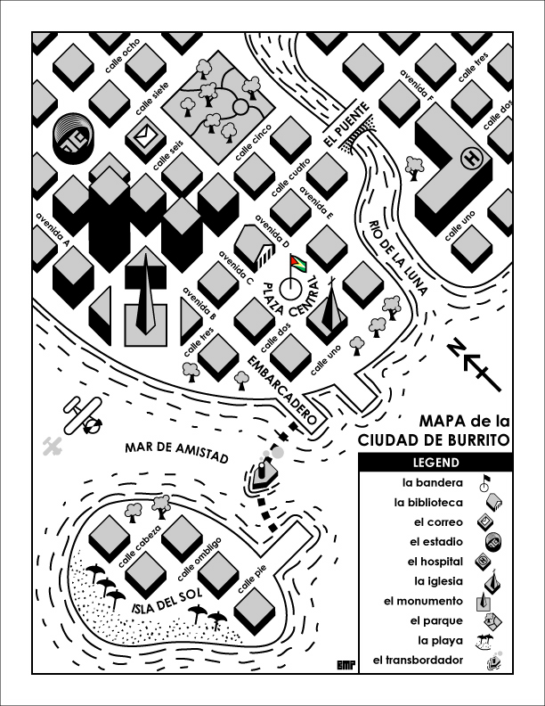

**Unidad: En la comunidad -**

**¿Adónde vas?**

I can use the irregular verb *IR* to give and get information about ***where someone is going***

I can use the irregular verb *IR* to give and get information about ***with whom someone goes*** somewhere

C:\Users\turnerk\AppData\Local\Microsoft\Windows\Temporary Internet Files\Content.IE5\94D6KTIO\MC900391148[1].wmf

**Learning targets /**

**Enfoque de aprendizaje**

I can communicate about ***when activities happen***

I can use the prepositional phrases ***al****…,* ***a la****…,* ***en la****…, etc.* to say **to the…, at/in the…**

I can use ***TENER que + inf***. to communicate about what people *have to do, their obligations*

I can use the expression ‘***para* + infinitive’** to say ‘in order + to …’

I can identify many ***places*** in a community

I can communicate about ***activities*** done ***at specific places*** in the community

**Vocabulario y gramática:**

|  |  |
| --- | --- |
| **Los lugares - places** | **Las actividades del tiempo libre-free time activities** |
| la biblioteca – the library | leer  estudiar  hablar  C:\Users\turnerk\AppData\Local\Microsoft\Windows\Temporary Internet Files\Content.IE5\94D6KTIO\MC900391148[1].wmfI can communicate about ***activities*** done ***at specific places*** in the community  investigar – to research |
| el café – the café  el restaurante – the restaurant | comer  beber  pasar tiempo con amigos  trabajar |
| el campo – the countryside  C:\Users\turnerk\AppData\Local\Microsoft\Windows\Temporary Internet Files\Content.IE5\94D6KTIO\MC900391148[1].wmfI can use the prepositional phrases ***al****…,* ***a la****…,* ***en la****…, etc.* to say **to the…, at/in the…**  C:\Users\turnerk\AppData\Local\Microsoft\Windows\Temporary Internet Files\Content.IE5\94D6KTIO\MC900391148[1].wmfI can identify many ***places*** in a community | caminar – to walk  C:\Users\turnerk\AppData\Local\Microsoft\Windows\Temporary Internet Files\Content.IE5\94D6KTIO\MC900391148[1].wmfI can use the expression ‘***para* + infinitive’** to say ‘in order + to …’  subir montañas  trabajar  sacar fotos  visitar  C:\Users\turnerk\AppData\Local\Microsoft\Windows\Temporary Internet Files\Content.IE5\94D6KTIO\MC900391148[1].wmfI can use ***IR a + infinitive*** to ask and talk about *near future* actions, what someone *is going to do*  montar a caballo – to ride a horse  pasear – to stroll/go for a walk  cazar – to hunt  ir de cámping – to go camping  ir de pesca – to go fishing |
| la casa – the house  en casa – at home  C:\Users\turnerk\AppData\Local\Microsoft\Windows\Temporary Internet Files\Content.IE5\94D6KTIO\MC900391148[1].wmfI can use the irregular verb *IR* to give and get information about ***where someone is going*** | descansar – to rest  C:\Users\turnerk\AppData\Local\Microsoft\Windows\Temporary Internet Files\Content.IE5\94D6KTIO\MC900391148[1].wmfI can use ***TENER que + inf***. to communicate about what people *have to do, their obligations*  ver la tele  comer  tocar el piano – to play the piano  limpiar – to clean |
| el centro comercial – the mall  el mercado – the market  el supermercado-the supermarket/grocery store | ir de compras – to go shopping  comprar – to buy  vender – to sell  pasear – to stroll/go for a walk |
| el cine – the movie theater | ver una película – to watch a movie  comer palomitas de maíz – to eat popcorn |
| el gimnasio – the gym | levantar pesas – to lift weights  hacer ejercicio – to exercise  jugar deportes |
| **Los lugares - places** | **Las actividades del tiempo libre-free time activities** |
| la iglesia – the church  la mezquita – the mosque  la sinagoga – the synagogue  el templo – the temple | rezar – to pray  escuchar  aprender  visitar |
| el parque – the park | jugar deportes  caminar  descansar  leer |
| la piscina – the pool  la playa – the lake | nadar  tomar el sol – to sunbathe  hacer* el esquí acuático – to water ski  *yo hago el esquí acuático = I water ski (the *yo* form of hacer is irregular) |
| el trabajo – the job, work | trabajar  ganar dinero – to earn money |
| la lección de piano – the piano lesson (class) | practicar  tocar el piano  aprender – to learn |

**ir – to go**

|  |  |
| --- | --- |
| yo voy = I go, am going, do go | nosotros/nosotras vamos = we go |
| tú vas = you go | vosotros/vosotras vais – you go |
| usted va = you go | ustedes van = you (all) go |
| él va = he goes | ellos van = they go |
| ella va= she goes | ellas van = they go |
| (it) va = it goes | (they – things) van = they go |

C:\Users\turnerk\AppData\Local\Microsoft\Windows\Temporary Internet Files\Content.IE5\94D6KTIO\MC900391148[1].wmfI can use the irregular verb *IR* to give and get information about ***where someone is going***

**ir a + lugar =** to go to a place

¿**Adónde** vas el sábado? (Where are you going on Saturday?)

* Voy **a la** playa y voy a nadar allí porque hace muy buen tiempo. ¿Y usted? (I’m going to the beach and I’m going to swim there because it is very nice weather. And you?)
* Voy **al** cine con mi familia para ver una película. (I’m going to the movies with my family (in order) to see a film.)

C:\Users\turnerk\AppData\Local\Microsoft\Windows\Temporary Internet Files\Content.IE5\94D6KTIO\MC900391148[1].wmfI can use the prepositional phrases ***al****…,* ***a la****…,* ***en la****…, etc.* to say **to the…, at/in the…**

Grammar notes:

* **a** = to (when a place follows)
* Use **adónde** when you ask **where** someone is going **to** *(their destination)*
* **a + el …🡪 al** = to the … This contraction is **required** in Spanish
* **a la, a las, a los, a un, a una, a unos, a unas –** no contraction needed

**Ir a + infinitive** = to be going to do the activity – to talk about the near future (gonna)

¿Qué **vas a hacer** el fin de semana? (What are you going to do on the weekend?)

Mis amigos y yo **vamos a ir** a una competencia de baile. (My friends and I are going to go to a dance competition.)

C:\Users\turnerk\AppData\Local\Microsoft\Windows\Temporary Internet Files\Content.IE5\94D6KTIO\MC900391148[1].wmfI can use ***IR a + infinitive*** to ask and talk about *near future* actions, what someone *is going to do*

**tener – to have**

|  |  |
| --- | --- |
| yo tengo = I have, do have | nosotros/nosotras tenemos = we have |
| tú tienes = you have | vosotros/vosotras tenéis – you have  C:\Users\turnerk\AppData\Local\Microsoft\Windows\Temporary Internet Files\Content.IE5\94D6KTIO\MC900391148[1].wmfI can use ***TENER que + inf***. to communicate about what people *have to do, their obligations* |
| usted tiene = you have | ustedes tienen = you (all) have |
| él tiene = he has | ellos tienen = they have |
| ella tiene = she has | ellas tienen = they have |
| (it) tiene = it has | (they – things) tienen = they have |

**tener que + infinitive** = to have to do the activity – to talk about obligations (hafta)

¿Cuándo **tienes que estudiar** ? (When do you have to study?)

Yo **tengo que estudiar** todos los días para aprender bien y cuando tengo un examen. (I have to study everyday in order to learn well and when I have a test.)

**¿Dónde?**- Where?

C:\Users\turnerk\AppData\Local\Microsoft\Windows\Temporary Internet Files\Content.IE5\94D6KTIO\MC900391148[1].wmfI can use the prepositional phrases ***al****…,* ***a la****…,* ***en la****…, etc.* to say **to the…, at/in the…**

**En** **el** campo voy a ir de pesca. – In the country I’m going to go fishing

Voy a investigar **en la** biblioteca. – I’m going to research at/in the library.

¿**Adónde?** Where to?

Voy a la biblioteca para investigar la historia de China. – I’m going to the library to research China’s history.

Voy al lago para tomar el sol. – I’m going to the lake to sunbathe.

C:\Users\turnerk\AppData\Local\Microsoft\Windows\Temporary Internet Files\Content.IE5\94D6KTIO\MC900391148[1].wmfI can use the irregular verb *IR* to give and get information about ***with whom someone goes*** somewhere

**¿Con quién?**- With whom?

**conmigo**-with me **contigo**-with you (inf/sing)

con usted – with you (form/sing) con unos amigos-with some friends

¿Con quién vas al parque para jugar fútbol después de las clases? – With whom are you to the park to play soccer after school?

¡Voy contigo! – I’m going with you!

**¿Cuándo? –** When? **¿Con qué frecuencia**…?-How often…

* **el + day of the week =** *on* the day of the week, no need to add more
  + **los lunes** = on Mondays **el domingo** = on Sunday **los fines de semana** = on weekends
  + después –afterwards
* después de+ infinitivo - after …ing después de comer - after eating
* después de +noun -after the thing después del* almuerzo –after lunch *(de + el = del) después de la prueba –after the quiz
  + a menudo-often
  + todos los días-everyday
  + generalmente-generally
  + siempre-always
  + mucho-a lot
  + en mi tiempo libre-in my free time
  + a veces-sometimes
  + nunca-never
  + a las ocho de la mañana-at 8:00am
  + demasiado-too much
  + un poco-a little

C:\Users\turnerk\AppData\Local\Microsoft\Windows\Temporary Internet Files\Content.IE5\94D6KTIO\MC900391148[1].wmfI can use the expression ‘***para* + infinitive’** to say ‘in order + to …’

**para + infinitive =**  (in order) to do the activity

**¿Para qué vas a estudiar mucho?** Why are you going to study a lot? **Voy a estudiar mucho para sacar notas buenas =** I’m going to study a lot in order to get good grades.

At the end of this unit, what should you be able to do? (Please refer back to the learning targets!)

What do you think would be a fair culminating assessment to show that you have achieved the learning targets? (I already have one in mind, but maybe your idea is better!) Please give ideas that will showcase your new knowledge and ability to communicate in the three different modes: interpersonal (speaking, writing), presentational (speaking, writing) and interpretive (reading, listening). This/these will be the assessment(s) that you must complete successfully to earn credit.